Weekly Project Meeting Minutes

**Date of meeting(s):** March 9th Group members(Name,ID):

* Yi Zhou 0730368
* Tejas Mahesh Patel: 0730241
* Soorya Suresh: 0735168
* Mohsin Meghjani: 0730241
* Seong Kyoung: 0725164
* Rajwinder Kaur: 0732989

**Specific Activities:**

* During last week, we decide to choose the topic about cryptocurrency analysis.
  + - * 1. Research more information about cryptocurrency

Nowadays, we have countless data more than the past 50 years. Data means money, that why bitcoins become more and more popular, the bitcoins of pricing are increasing every year. Customer using cryptocurrency to buy bitcoins, especially, in blockchain

* + - * 1. Importing dataset by Python, Checking each column in dataset.

Specific Output from prior week:

* Main Goals: our goal is to find out the cryptocurrency which have the low volatility.
* We have 8 columns * 28944 rows. 8 columns including:

Currency name: e. g bitcoin

Date: Date refers to the calendar date for the particular row- 24 hours, midnight to midnight

High: Highest recorded trading price of the day

Low: Lowest recorded trading price of the day

Volume: Volume represents the monetary value of the currency traded in a 24hour period, denoted in USD.

Market cap: Market cap is circulating supply x price of the coin. For example, if you have 100 coins that are worth $10 each your market cap is $1.000

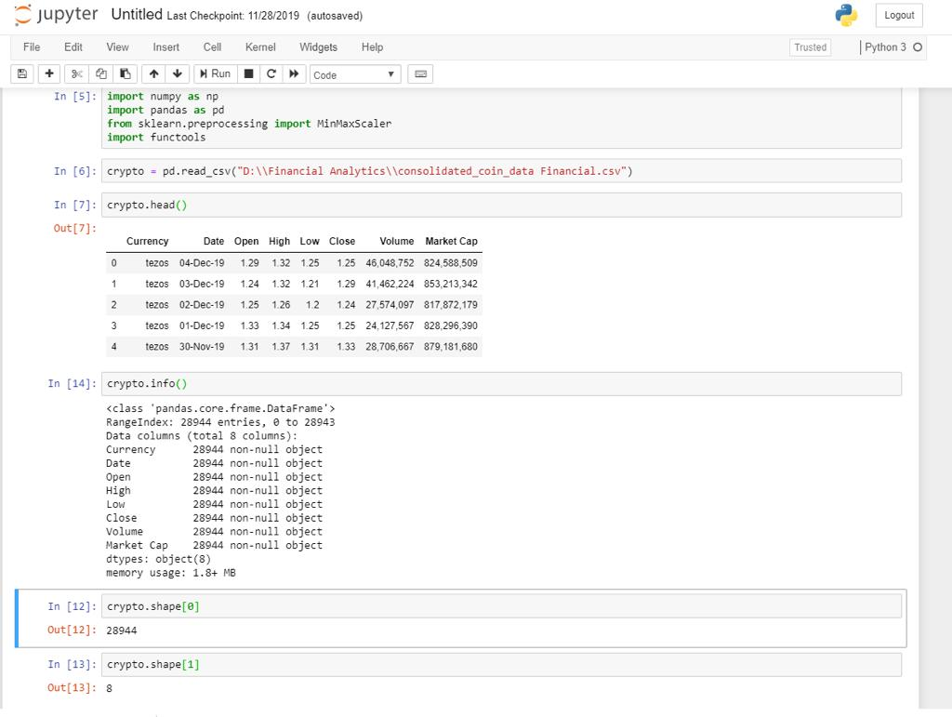

**On Target:**

* green: everything on track for completion by due date.

**Activities by group members**: Each activity+ was shared equally among the group members.

We are researching blockchain ad understanding more about

Cryptocurrency.

Yi zhou, Soorya, Rajwinder and Mohsin is doing the reporting

Tejas and Seoung is doing the modelling.

**Challenges:**

* Our main challenge is to find the right algorithm for prediction.

**Planned Activities for coming week:**

* **We will be exploring our dataset in more depth and bring out some possible algorithms to predict the model.**

**Data source:** [**https://www.kaggle.com/philmohun/cryptocurrency-financial-data**](https://www.kaggle.com/philmohun/cryptocurrency-financial-data)